|  |  |  |
| --- | --- | --- |
|  |  |  |

**Smart Bin Management System**

**COMP225-**

Business Requirements

Document

|  |  |
| --- | --- |
| **Prepared by** | **Contact number** |
| **SIMRANJEET KAUR** | **300988063** |
| **SUMIT MITTAL** | **300980027** |
| **RAMANDEEP KAUR** | **300987689** |
| **ANGELENE ABRAHAM** | **300988043** |
| **ALBIN ANTONY** | **300981814** |

**VERSION HISTORY**

|  |  |  |  |  |
| --- | --- | --- | --- | --- |
| **Version** | **Date** | **Description** | **Changed by** | **Approved by** |
| 1.0 | 15-JUN | Improvement in Vision document and implementing changes to activity diagram. | Simran and Angelene | Sumit , Albin and Raman |
| 1.1 | 22-JUN | Use case diagram amended as suggested by professor | Sumit , Albin and Raman | Simran and Angelene |
| 1.2 | 1-JUL | Insufficient resources to implement in its working so focused on its management and business | Sumit , Raman and Simran | Angelene and Albin |
| 1.3 | 17-JUL | Changes in domain class diagram and ERD according to the whole project | Angelene, Simran and  Albin | Raman and Sumit |
|  |  |  |  |  |

**Table of Contents**

*1.0* *Business Opportunity Definition 5*

1.1 Business Problem or Opportunity 5

1.2 Business Objectives 5

1.3 Business Scope 5

1.3.1 Context Diagram (External View) 5

1.3.2 High Level Scenario (Internal View) 5

1.3.3 In Scope 5

1.3.4 Out of Scope 5

1.4 Project Stakeholders/User 6

*2.0* *Business Activities 7*

*3.0* *Requirements 9*

3.1 Use Case Analysis 9

3.2 Class Diagrams 16

3.3 Gantt Chart 18

3.4 System Sequence Diagrams 19

3.5 State Machine Diagram 20

**Table of Tables**

**Table 1 - Business Opportunity Description** **5**

**Table 2 - In Scope Business Activities** **5**

**Table 3 - Stakeholder Value** **6**

**Table 4 - Business Requirements** **9**

**Table 5 - UC #1 Primary Scenario 11**

**Table 6 - UC #2 Primary Scenario 13**

**Table 7 - UC #3 Primary Scenario 15**

**Table 8 - Class Diagram 16**

**Table of Figures**

**Figure** **1.1 -** **CMO****7**

**Figure** **1.2 - FMO** **8**

**Figure 3.1** **- System Interactions** **9**

**Figure 3.2** **- Customer Interactions** **12**

**Figure 3.3 - User** **and System Interactions** **14**

**Figure 3.4 - Class Diagram 17**

**Figure 3.5 - Gantt Chart 18**

**Figure 3.6 - System Sequence Diagram - Use case 2 19**

**Figure 3.7 - System Sequence Diagram - Use case 3 19**

**Figure 3.8 - System Sequence Diagram - Use Case 1 and 3 20**

# 1.0 Business Opportunity Definition

## Business Problem or Opportunity

|  |
| --- |
| **Business Problem - Opportunity Description** |
| The disposal of garbage is already managed properly by the Ontario management as they have laid a proper Rules to segregate the waste. However, it happens that wrong waste is put in the wrong bins and hence, causing inconvenience in whole process at waste-disposal sites. For example, while decomposition of degraded items, even recyclable products (plastic, cans, polythene) are dumped along with non-recyclable ones and slows down the process. In the meantime, the newly arrived smart bin maybe a possible solution for this problem but it hasn’t been popularized nor it’s distribution and management been very plausible. This problem is solved by our Smart Bin Management System . The main purpose of this business is to sell as much units as possible which will help in segregation of the garbage. |

**Table 1 - Business Opportunity Description**

## Business Objectives

* The business manager must set clear financial objectives to emphasize the financial targets of the company.
* Business mangers establish objectives that focus on providing quality customer service. These objectives attempt to measure customer satisfaction with costs and overall quality of a product or service.

## Business Scope

### In Scope

|  |
| --- |
| **In-Scope – Business Activities** |
| * Increase timely communication between sales and shipping department through the improved system generated like an orderid makes it easy to process the order. |
| * Maintain correct and current data about suppliers and their employees. |
| * This system will increase sales revenues which would result in meeting sales objectives at higher extent. |
| * Updating the latest images about new product on online website to help advertising it. |

**Table 2 - In Scope Business Activities**

### Out of Scope

* The production and supply of the product needs more time and resources for global sale.

## Project Stakeholders/User

|  |  |  |  |  |  |
| --- | --- | --- | --- | --- | --- |
| **Stakeholder/ User** | **Quantity (Users)** | **Role in Process** | **Major Value of Project** | **Major Interests** | **Major Concern** |
| Sponsor | 1 | Set Up meeting with Project manager,  Supervision of how Project manager will use the resources. | Provide Financial Support | Generate more profits and increase the sales of the company | May stop to provide funding and might reduce line of credit in future if resulted in less profit |
| Project Manager | 1 | Plan, organize, Lead and administrate the project. | Organise Project | Administrate the resources and time effectively | Deploy the update in the proposed time without any problem |
| Customers | 250 | Buying the smart bin, online or through placing an order on the phone  And using it without any issues | Customers are the people who buy this project and do business with the category | Easy way to order and maintain the product from home without having to visit the stores for purchasing or customer support needs | Receive the product in timely manner  No problem in ordering process. |
| Shipping Specialist | 30  Across Canada | Ship the product to the customer and assembles it for the customer. | Shipping Dept. prepare the shipment of garbage disposal system for the customers | Make sure it contains everything inside the shipping Box | The system is too fragile to ship to farther distances |

**Table 3- Stakeholder Value**

# Business Activities

## Current Mode of Operation

< Activity / Workflow Diagram)

**Figure 1.1(a): CMO**

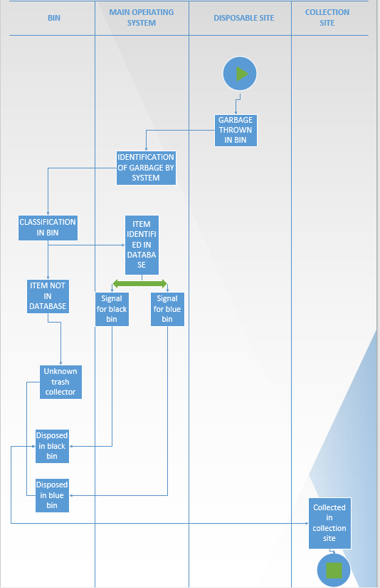

**Figure 1.1(b): CMO**

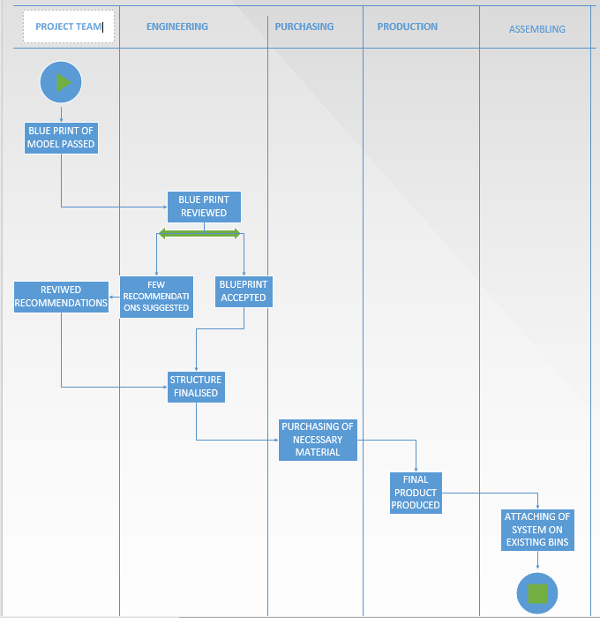

## Future Mode of Operation

<Activity / Workflow Diagram

**Figure 1.2: FMO**

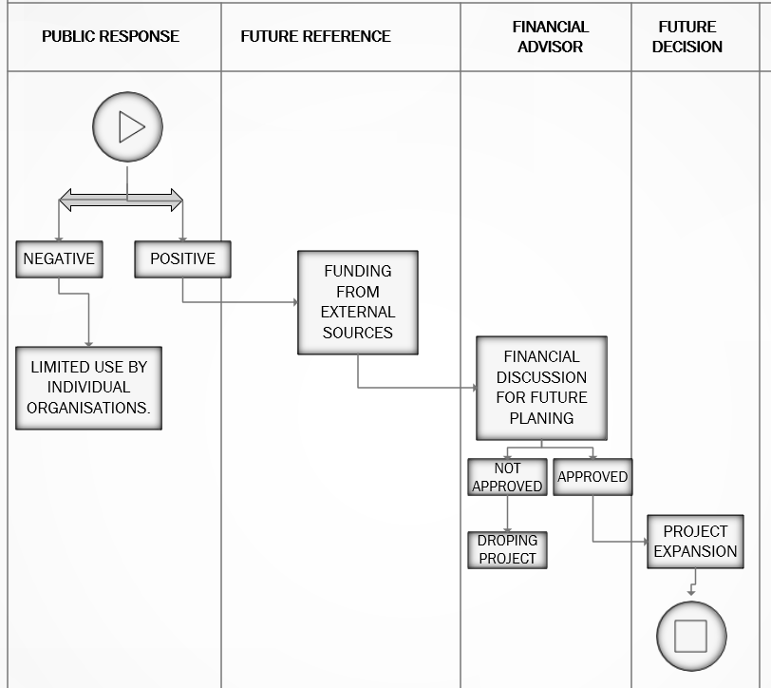

# Requirements

|  |  |
| --- | --- |
| **Related Documents** | **Location (K-Store folder URL)** |
| **Recommended Approach**  ***All*** *requirements shall be documented in the Requirement Management Tool.*  *This includes the* ***Business Requirements****,* ***Functional*** *(to be mechanized functions), manual process requirements,* ***information*** *requirements &* ***non-functional*** *requirements.* | ***Alternate (secondary) Approach***  *The Business Requirement Management Matrix may also be used to capture the Business requirements as derived from the Business* |

**Table 4 - Business Requirements**

## 

## 3.1 Use Case Analysis

**Use Case DIAGRAM #1:**

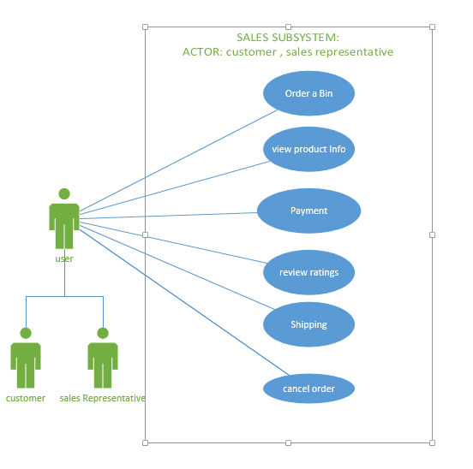

**User story(use case 1)**

User finds the desired order information, by reviewing the product ratings and comments. Once finalized, the user places an order, either from website or by making a call to a CSR (customer sales representative) who enters First Name, Last Name or customer Id (if possible).

User selects the shipping method for the order.

User adds/updates the shipping information of the order.

User authorizes and captures the payment for the order. (The payment can be done through debit or credit card.)

User can cancel existing payments and can add new payments (Offline/Credit Card).

At any point of time the order can be cleared/removed from the system if the customer declines to go ahead with the order placement i.e. the user have option for cancelling the order.

SUB SYSTEM: **SALE SUB-SYSTEM**

|  |  |  |  |  |
| --- | --- | --- | --- | --- |
| # | Goal use case name | Actor(s) | Brief description | Priority(H,M,L) |
| 1 | Order a Bin | Customer, Sales Representative | The customer can place an order on the website of the company for the bin or call a sale representative to place an order | H |
| 2 | view product Info | Customer, Sales Representative | The user can view the information about the product and its uses. | L |
| 3 | Payment | Customer, Sales Representative | The user makes a payment and receive receipt. | M |
| 4 | review ratings | Sales Representative,  customer | The customer can review and analyse the old reviews of the buyers so as to know how much is its rating. | H |
| 5 | Shipping | Sales Representative | The order is shipped to customer. | H |
| 6 | cancel order | Sales Representative,  customer | the user can cancel the order at any time until the order is shipped from the depository | H |

Table #5

**Use Case DIAGRAM #2:**

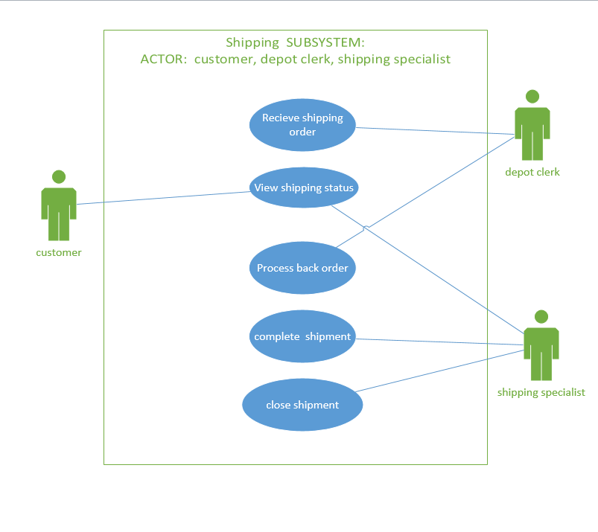

**User story(use-case 2)**

Order is received by the depot clerk from user (customer / sales representative) who reviews the product information which customer had specified to CSR (or as specified online).

Then being reviewed, the clerk adds desired product into the order, specifying the quantity requested.

These details are passed to shipping specialist who can quickly finalize the order ahead.

If the shipping information are available in the system then it is available on shipping specialist screen, and if it is not then shipping specialist adds it. After selecting shipping information, shipping specialist selects the shipping method available in the system. He is able to ship the order in multiple batches in case of any item is not available in the inventory and for this he splits shipment of the order and at same time updates the depot clerk for processing the back order. Once the order has been finalized, shipping specialist completes order and updates the required shipping status. Shipping specialist closes shipments and complete the shipment in the Shipping Que.

At any point of this process the customer and the shipping specialist can track the shipping status through shipping id provided.

SUB SYSTEM: **SHIPPING SUB-SYSTEM**

|  |  |  |  |  |
| --- | --- | --- | --- | --- |
| # | Goal use case name | Actor(s) | Brief description | Priority(H,M,L) |
| 1 | Receive shipping order | Depot clerk | The order is received and analysed by depot clerk. | H |
| 2 | View shipping status | Shipping specialist, customer | The shipping status can be viewed by either customer or shipping specialist. | H |
| 3 | Process back order | Depot clerk | Depot clerk is responsible for checking the availability and to withhold the order in case of unavailability. Finally, he can process the order once it becomes available. | M |
| 4 | complete shipment | Shipping specialist | The shipment is then completed by specialist. | M |
| 5 | close shipment | Shipping specialist | Shipping specialist reconcile shipments and complete the shipment in the Shipping Que. | H |

Table #6

**Use Case DIAGRAM #3:**

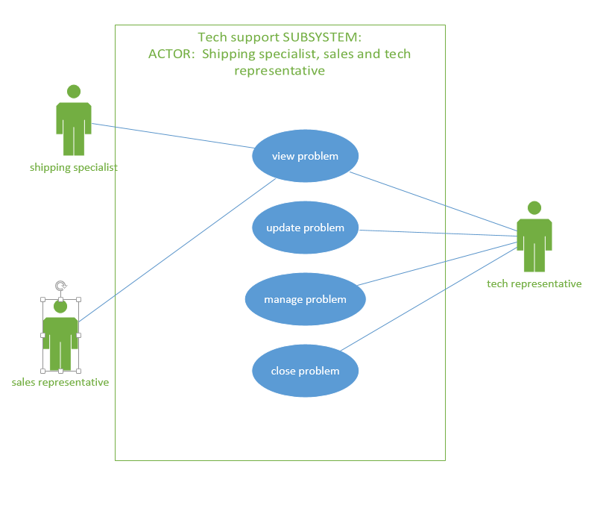

**User story (use-case 3)**

In case, the customer finds the shipped product to be faulty or if the customer decides that he/she does not want the shipped product, they contact the CSR by phone or email and requests for solving the problem. For handling the issue, both sales as well as shipping specialist have access to review this information. Further, it is tech representative who inspects the problem in system and manages it to solve.

If a problem has not been recognised properly the tech representative may return it to the Helpdesk for proper re-assignment.

If the problem can be troubleshooted over phone, the tech representative sends the solution to the user and gives a walk-through at the same time.

Else, the tech representative sends a support team and manages the issue. Once the issue is resolved the tech representative is updated who sends a confirmation mail to the user to confirm the repairs and hence closes the problem.

SUB SYSTEM: **Tech Support**

|  |  |  |  |  |
| --- | --- | --- | --- | --- |
| # | Goal use case name | Actor(s) | Brief description | Priority(H,M,L) |
| 1 | view problem | Tech representative, shipping specialist, sales representative | The tech representative, shipping specialist and sales representative can view the problem. | H |
| 2 | update problem | Tech representative | The Tech representative record and files each and every detail of the complaint and updates the status of the problem and the possible time required to fix that issue. | H |
| 3 | manage problem | Tech representative | After analysing the issue, the representative calls the suitable department to resolve the issue. | M |
| 4 | close problem | Tech representative | After the issue has been dealt with the issue is resolved | M |

Table #7

## 

## 3.2 Class Diagrams

|  |  |
| --- | --- |
| **Identified Noun** | **Notes on including noun as a thing to store** |
| Order | The customer places it and its details must be stored. |
| Customer | Places the order. The details of the customer is to be stored. |
| Shipping Details | The details of the product shipment. The details are to be stored. |
| Stock Availability | The product availability information. No needed to be stored. |
| Payment | The payment. Details are to be stored. |
| Bill | The payment receipt. Must be stored for any further enquiries and references. |
| Delivery | Status of the product shipment. Must be stored. |
| Confirmation | The status of the product order. No need to be stored. |
| Cancellation | The status of the product order. No need to be stored. |
| Enquiry | FAQ’s regarding the product. Must be stored. |
| Complaint | Complaints regarding the product or the service. Must be stored |
| Technical Support | The technical team for the product. No need to be stored |
| Sales Department | Sales representatives for the product. No need to be stored. |

**Table 8 - Class Diagram**

**Figure 3.4: Domain Class Diagram (part c changes)**

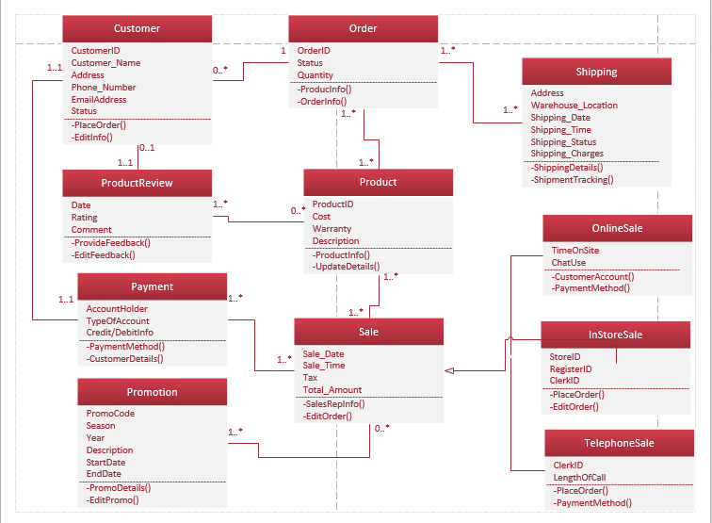

**Figure 3.5 ERD**

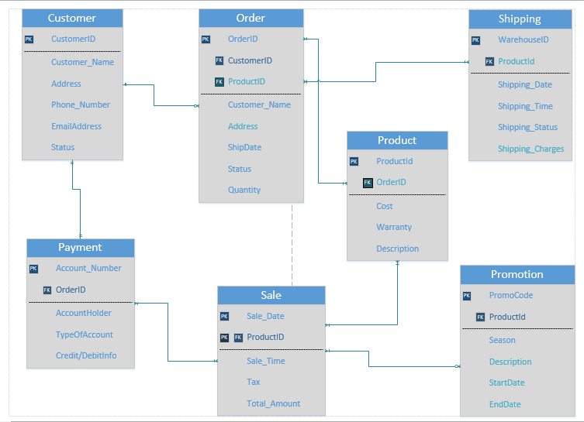

## 

## 3.3 Gantt Chart

Attached project file :-



**Figure 3.5 - Gantt Chart**

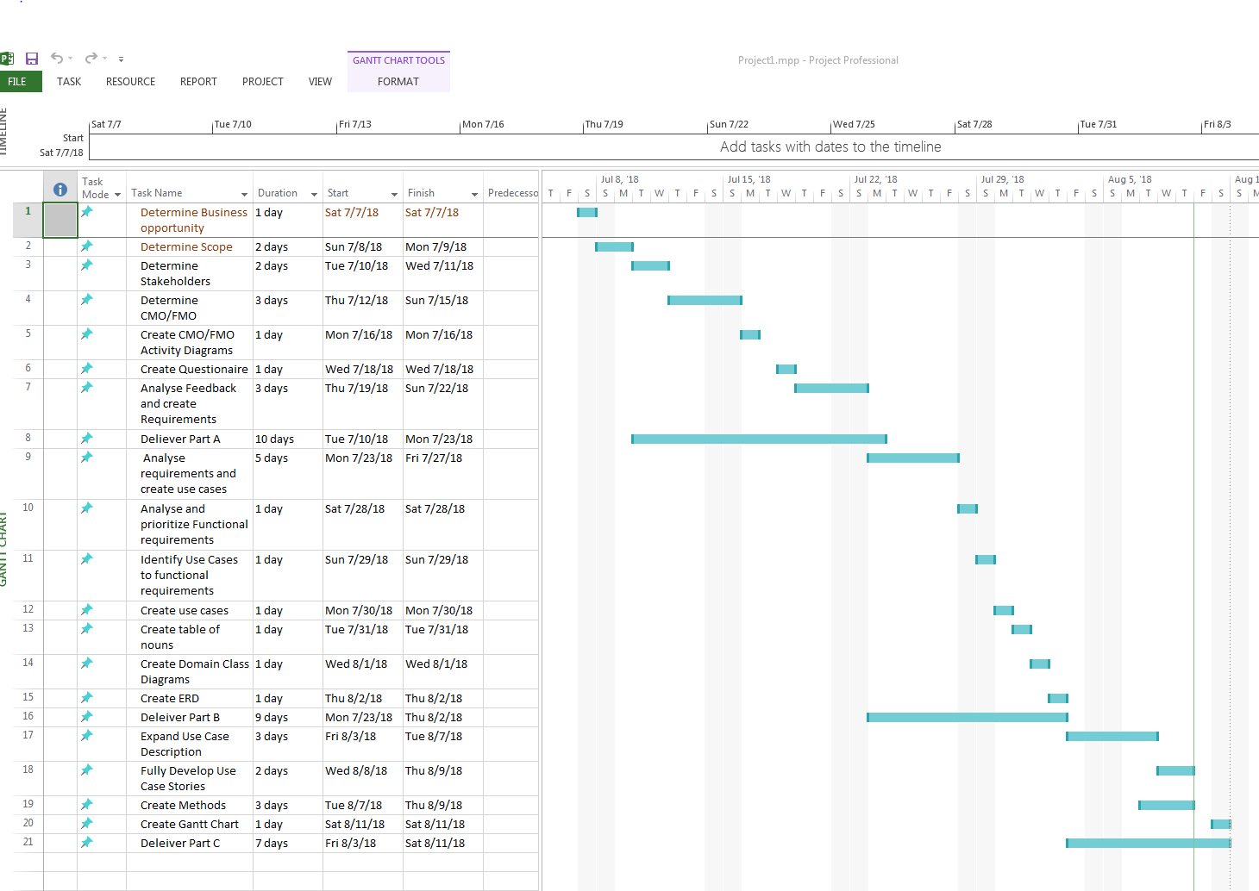

## 

## 

## 3.4 System Sequence Diagrams

**Figure 3.6 –**

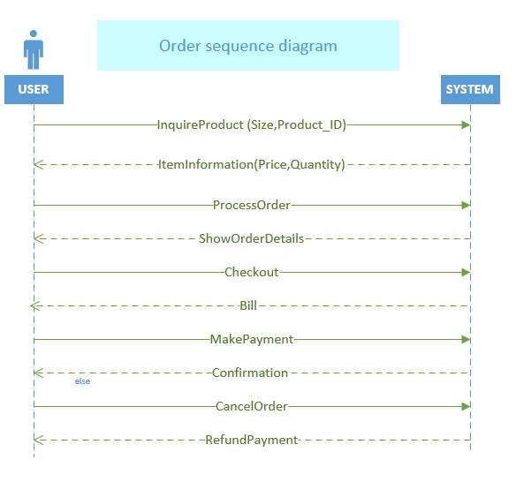

**Figure 3.7 –**

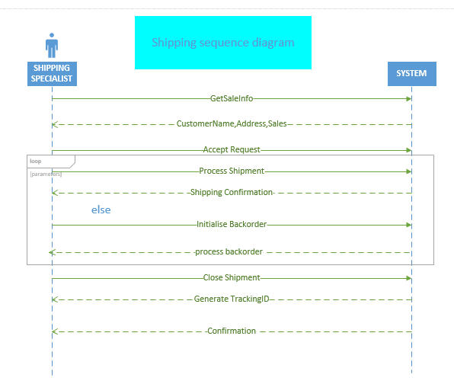

## 

## 3.5 State Machine Diagram

**Figure 3.8 –** 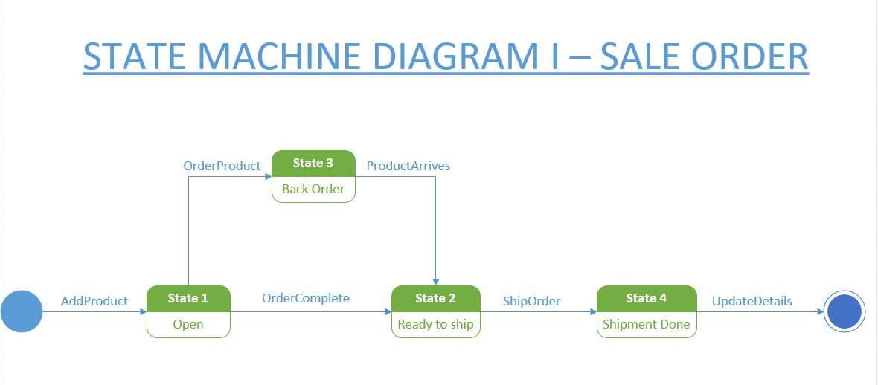

**Figure** 3.9 –

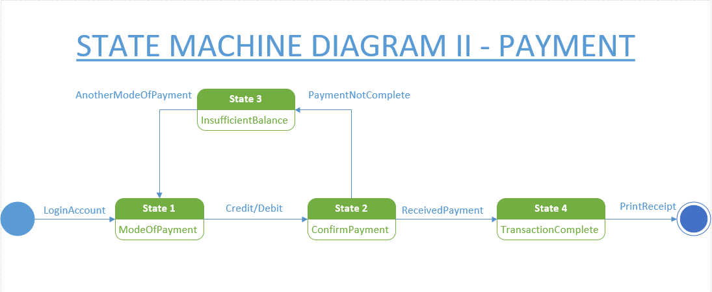

Thank you.

X**************************************************************************X